Hierarchy Text
Existing representations of fund and ETF allocation information can be organized by their structural paradigms and primary use cases into three distinct categories: Regulatory & Compliance Models, Operational & Commercial Aggregators, and Semantic & Knowledge Representations.
First, Regulatory & Compliance Models are designed for mandatory oversight and public accountability. This category has evolved from unstructured narrative documents (such as U.S. SEC Forms N-SAR and N-Q) into machine-readable formats, including structured XML filings for position holdings (Form N-PORT) and census reporting (Form N-CEN), alongside semantic XBRL taxonomies used for tagging prospectus summaries.
Second, Operational & Commercial Aggregators prioritize market mechanics and cross-fund analysis. This includes high-frequency dated ETF allocation disclosures—such as provider factsheets and product-page allocation summaries driven by U.S. SEC Rule 6c-11 to support pre-market operations—and commercial databases like Morningstar. These proprietary databases normalize heterogeneous holdings data into standard relational schemas for easier investor benchmarking.
Finally, Semantic & Knowledge Representations focus on formal, cross-system interoperability. This category includes standardized financial ontologies like the Financial Industry Business Ontology (FIBO) and academic semantic applications such as GFRO, which use RDF/OWL to define shared industry concepts.
While these models successfully support regulatory audits, daily trading, and high-level conceptual definitions, our project targets a specific opportunity. We propose an explicit semantic pattern that links a dated ETF allocation disclosure to its source provenance, underlying entries, and classification scheme.

Mermaid Vertical Graph
graph LR
Root["Representations<br>of ETF & Fund<br>Allocations"]

%% Regulatory Branch
Root --> Reg["Regulatory &<br>Compliance<br>Models"]
Reg --> Reg1["U.S. SEC Narrative<br>Filings (N-SAR, N-Q)"]
Reg --> Reg2["Structured XML Holdings<br>(N-PORT) & Census (N-CEN)"]
Reg --> Reg3["Tagged Taxonomies<br>(XBRL)"]

%% Operational Branch
Root --> Ops["Operational &<br>Commercial<br>Aggregators"]
Ops --> Ops1["Dated ETF Disclosures<br>(Factsheets, Product Pages)"]
Ops --> Ops2["Aggregated Databases<br>(Morningstar)"]

%% Semantic Branch
Root --> Sem["Semantic &<br>Knowledge<br>Representations"]
Sem --> Sem1["Industry Ontologies<br>(FIBO)"]
Sem --> Sem2["Academic Extensions<br>(e.g., GFRO)"]

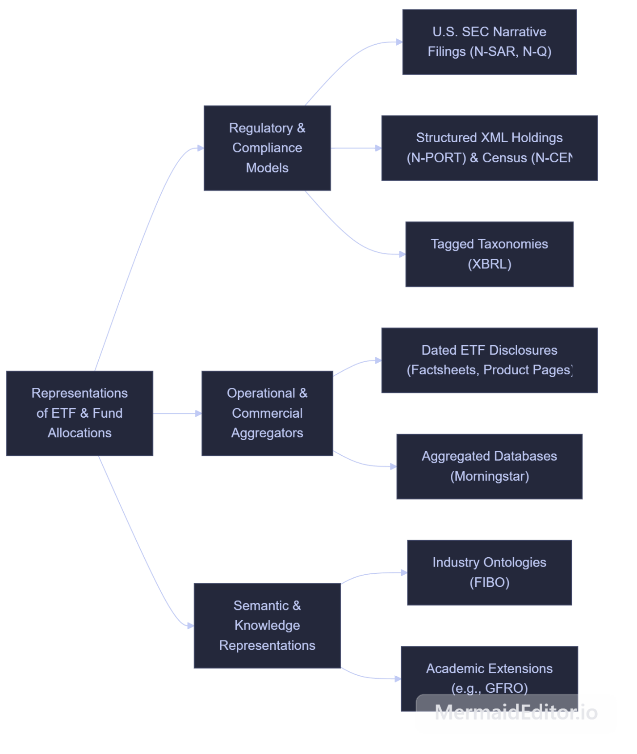

Mermaid Horizontal Graph
graph TD
Root["Representations of ETF<br>& Fund Allocations"]

%% Regulatory Branch
Root --> Reg["Regulatory &<br>Compliance Models"]
Reg --> Reg1["U.S. SEC Narrative Filings<br>(N-SAR, N-Q)"]
Reg --> Reg2["Structured XML Holdings (N-PORT)<br>& Census (N-CEN)"]
Reg --> Reg3["Tagged Taxonomies<br>(XBRL)"]

%% Operational Branch
Root --> Ops["Operational & Commercial<br>Aggregators"]
Ops --> Ops1["Dated ETF Disclosures<br>(Factsheets, Product Pages)"]
Ops --> Ops2["Aggregated Databases<br>(Morningstar)"]

%% Semantic Branch
Root --> Sem["Semantic & Knowledge<br>Representations"]
Sem --> Sem1["Industry Ontologies<br>(FIBO)"]
Sem --> Sem2["Academic Extensions<br>(e.g., GFRO)"]

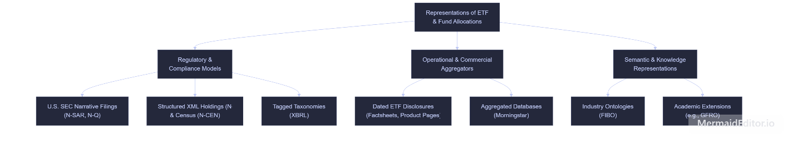
Gap Statement
The Financial Industry Business Ontology (FIBO) provides a standardized vocabulary for financial concepts like funds, portfolios, and reporting dates. While previous research, such as the GFRO application by Browne et al., successfully extends FIBO to support dated point-in-time fund reporting, the reviewed material does not describe our particular integrated pattern.
Specifically, there remains an opportunity to define a lightweight, reusable application pattern linking an ETF directly to its allocation date, percentage entries, categories, classification context, and supporting source document. Furthermore, this proposed model explicitly distinguishes an empirical allocation observation—what a provider actually reported on a given date from a fund's general investment policy, which defines limitations on what the fund is allowed to hold. This pattern addresses the gap by integrating ETF allocation snapshots while preserving their original source provenance.

FIBO Concept Verification & Gap Validation
Text for the Team / Appendix:
1. FIBO Modules for Reuse and Concept Verification
After auditing the relevant Financial Industry Business Ontology (FIBO) modules (inspected at the pinned October 1, 2026 revision), I have verified our team's proposed semantic mappings and reuse decisions:
- Classification vs. Categories: In the CollectiveInvestmentVehicles.rdf module, FundClassification and FundClassificationScheme classify an entire collective investment vehicle by its broad fund type (e.g., equity vs. fixed income). This confirms Taimoor’s finding: these concepts do not represent individual observed holding categories like "Technology" or "Canada" within a fund. We will need generic classifier concepts for our AllocationCategory entity.
- Policy vs. Observation: FIBO uses the property definesAllocations to link a FundPortfolioInvestmentPolicy to specific portfolio investment limitations. This defines a normative constraint on what a fund is permitted to hold. Therefore, our ER diagram correctly represents an ETF breakdown as a dated, empirical observation of a disclosure, rather than an investment policy constraint.
- Baskets & Dates: In the FinancialProductsAndServices.rdf module, the WeightedBasket concept requires a weighted constituent and a specific weighting expression. A disclosure is high-level information about an ETF, so it should not automatically be typed strictly as an investment basket. Furthermore, in FinancialDates.rdf, hasAsOfDate is an object property that links to a structured date individual, not a direct date-valued literal. Our later RDF mapping must handle this date structure explicitly.
- Publishers & Portfolios: FIBO’s Ownership.rdf module defines Portfolio as a collection of holdings, while the Publishers.rdf module defines Publisher as a functional party role. Our model's ETFProvider entity records an organization, acknowledging that an organization may play a publishing role without being identical to the role itself.
2. Gap Validation Against Prior Literature To ensure our project advances the state of the art, I reviewed the 2017 application of FIBO by Browne et al., which developed the Global Fund Reporting Ontology (GFRO).
- Prior Work Scope: Browne et al. demonstrate point-in-time fund graphs and geographic/sector summaries using FIBO.
- Proposed Integration Gap: While GFRO covers dated fund reporting, the reviewed material does not explicitly detail a lightweight integration pattern linking a provider-published website disclosure (factsheet) directly to its captured source document, publication timestamp, underlying percentage entries, and classification context.
- Positioning Our Contribution: Our project does not claim that FIBO lacks the capability to represent weights, dates, or classifications. Instead, we propose a narrow, explicit application pattern that bridges this integration gap, ensuring that published ETF allocations retain their source provenance and semantic meaning.

Citations

@inproceedings{browne2017semantic,
title={Semantic Ontologies and Financial Reporting: An Application of the FIBO},
author={Browne, Oliver and Krdzavac, Nenad and O'Reilly, Philip and Hutchinson, Mark},
booktitle={Proceedings of the Joint Ontology Workshops 2017},
volume={2050},
series={CEUR Workshop Proceedings},
year={2017}
}
@misc{fibo2026,
author={{EDM Council}},
title={Financial Industry Business Ontology (FIBO)},
howpublished={\url{https://spec.edmcouncil.org/fibo/}},
note={Pinned revision examined October 1, 2026},
year={2026}
}

Addition for Masons Comparision table.
Existing Model: GFRO (Browne et al.) / Prior Academic Work

Main Purpose: Point-in-time semantic fund reporting and regional summaries.
Key Entities: Fund; Geographic Region; Sector; Currency.
Key Relationships: Fund has regional/sector allocations at a point in time.
Strengths: Demonstrates practical FIBO extension for aggregated fund reporting.
Limitations: Lacks a lightweight pattern for daily ETF disclosures; omits source document provenance and classification scheme context.
Implications for ER Design: Validates the use of formal semantics but confirms the gap for an explicit source-attributed disclosure pattern.
Things to do
1. Primary Lead Deliverables (Hierarchy Section & Figure)
- Draft the Hierarchy Section Text (Target: ~150–250 words):
  - Group existing representations of fund/ETF data into a coherent, two-level taxonomy based on purpose, modeling paradigm, or data structure.
  - Synthesize the six paradigms identified by Mason into clear structural categories:
    - Regulatory & Compliance Models: Narrative/document filings (SEC EDGAR Form N-SAR/N-Q), structured XML filings (Form N-PORT/N-CEN), and tagged summary prospectuses (XBRL).
    - Operational & Commercial Aggregators: Issuer pre-market website disclosures (Rule 6c-11 HTML/PDF/CSV) and normalized analytical databases (Morningstar).
    - Semantic & Knowledge Representations: Formal financial ontologies (FIBO) and semantic extensions (GFRO).
  - Explain why these divisions exist (e.g., regulatory oversight vs. pre-market arbitrage vs. cross-system semantic interoperability) and highlight the gap your project fills.
- Create the Hierarchy Figure (Taxonomy Diagram):
  - Design a simple tree or block diagram illustrating these categories, subcategories, and representative standards/formats.
  - Ensure it can be exported as a clean vector graphic (PDF) or high-resolution PNG to insert directly into the ACM two-column LaTeX document.
2. FIBO Concept Verification & Gap Validation (Requested by Taimoor)
- Audit FIBO Modules for Reuse:
  - Classification & Categories: Inspect FBC/ProductsAndServices/FinancialProductsAndServices.rdf and generic classifier modules. Verify Taimoor's finding that FundClassification / FundClassificationScheme classifies the fund type (e.g., equity vs. fixed income) rather than individual observed holding/allocation categories (e.g., Technology, Financials, Canada).
  - Policy vs. Observation: Confirm that FIBO's definesAllocations connects a fund to an investment policy/limitation (e.g., target caps) rather than a dated historical disclosure event.
  - Baskets & Dates: Check WeightedBasketConstituent and verify that hasAsOfDate is an object property linking to a structured date individual rather than a plain literal datatype.
  - Publishers & Portfolios: Review BE/FunctionalEntities/Publishers.rdf (Publisher role) and FND/OwnershipAndControl/Ownership.rdf (Portfolio) to confirm how they interface with ETFProvider and Customer.
- Validate the Gap against Prior Literature (Browne et al. / GFRO):
  - Review the 2017 paper by Browne et al., Semantic Ontologies and Financial Reporting: An Application of the FIBO (CEUR Vol. 2050).
  - Confirm that while GFRO models point-in-time fund reporting and aggregated summaries, it omits an explicit, lightweight pattern linking a dated provider website disclosure directly to source provenance, underlying classification schemes, and category entries.
  - Document this as a specific application/integration gap rather than claiming FIBO completely lacks concepts of dates or weights.
3. Review & Co-Author Tasks
- Review Taimoor’s Draft ERD:
  - Inspect CSC501_M2_Taimoor_ERD.pdf against your competency questions (CQ1–CQ6).
  - Check cardinalities and relationships:
    - ETF $↔$ AllocationSnapshot ($1:N$).
    - AllocationSnapshot $↔$ AllocationEntry ($1:N$).
    - AllocationCategory $↔$ ClassificationScheme ($N:0..1$).
    - AllocationSnapshot $↔$ SourceDocument ($N:1$).
  - Ensure all attributes needed for your later RDF/OWL conversion (e.g., allocationAsOfDate, contextKey, sourceLocator, retrievedAt) are present.
- Contribute to the Comparison Table:
  - Review Mason’s Table 1 draft.
  - Verify or expand rows for:
    - FIBO Semantic Ontology: Reinforce strengths (formal semantics, extensible) vs. omissions (lacks observation-level disclosure events and factsheet provenance).
    - GFRO / Prior Academic Work: Add or verify a dedicated row contrasting Browne et al.’s fund ontology with your proposed pattern.
- Cross-Review Report Narrative:
  - Coordinate with Mason and Taimoor during the Tuesday meeting to ensure Mason’s history, your hierarchy, and Taimoor’s ERD description form a single flowing narrative.
4. Git & Submission Compliance Checks
- Preserve Original Student Writing:
  - Save your raw, unedited written drafts of the hierarchy section and FIBO notes into a standalone file.
  - Add this text to Appendix A / C (AI-Assisted Editing appendix) of the LaTeX template as mandated by the course guidelines.
- Git Repository Traceability:
  - Push your commits (hierarchy text, figure source files, table edits, notes) directly to your team’s repository (gitlab.uvic.ca or GitHub) using your individual student account to ensure your contribution record is preserved.
- LaTeX Layout & Length Verification:
  - Verify that the compiled PDF conforms strictly to:
    - Pages 1–2: Written text, hierarchy figure, comparative table, references (ACM two-column sigconf format).
    - Page 3: Dedicated one-page draft ER diagram and caption.
    - Following Pages: Appendix containing raw student drafts.
  - Ensure graduate students are ordered properly in the author list as specified by the manual.
- Packaging:
  - Confirm the final archive is zipped as 2_Background_firstname1_firstname2_[...].zip containing all .tex, .bib, figure files, and the compiled 3-page PDF (+ appendix) before the October 7 deadline

